Rolling Thunder®, Inc. Indiana Chapter One Ride to the Middle East Conflicts Wall Memorial Marseilles, Illinois
June 18 thru June 20, 2021

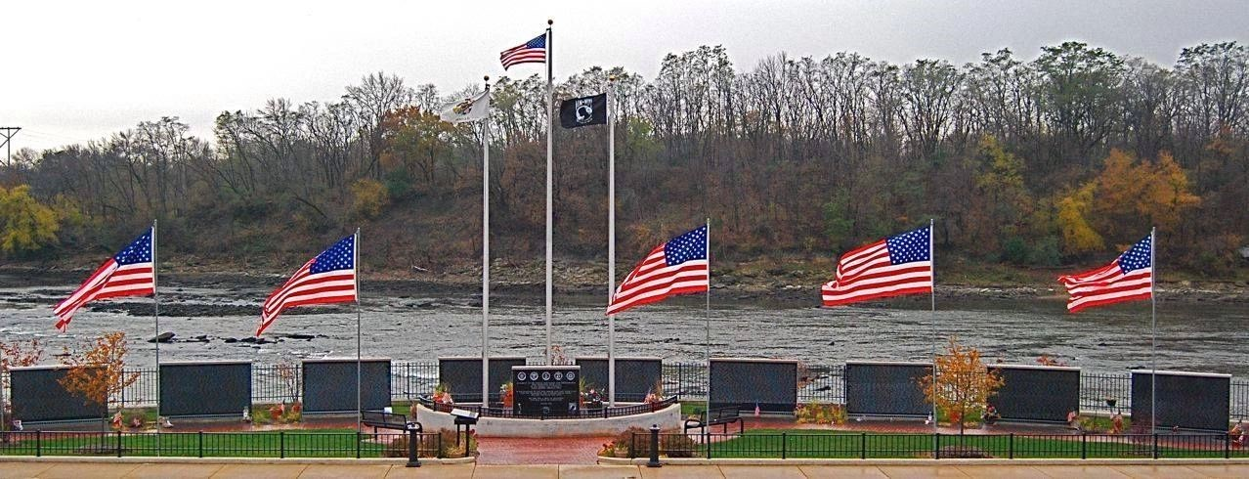

Ride with Rolling Thunder®, Inc. Indiana Chapter One on their third annual ride to Marseilles, IL to participate in the Illinois Motorcycle Freedom Run to Honor our Global War on Terror fallen Heroes and their families.

We will meet at the Fort Harrison Veterans Center to register and prepare for departure. After everyone has registered we will depart Indianapolis. IN to Morris, IL. The distance to Morris, IL is approximately 200 miles. The route will include a couple stops to pick up riders along the way, fuel, and lunch. Automobiles are welcome as well.

See details on back of flyer

We Don’t Know
Them All

But

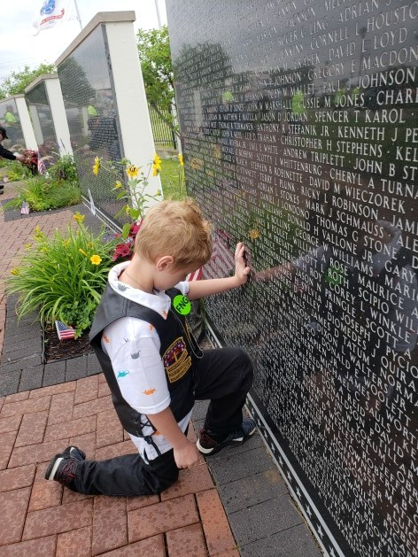We Owe Them All

Police Escort from Grundy County
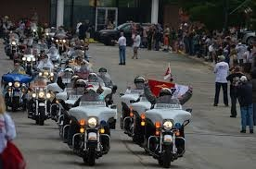Fairgrounds to the Memorial

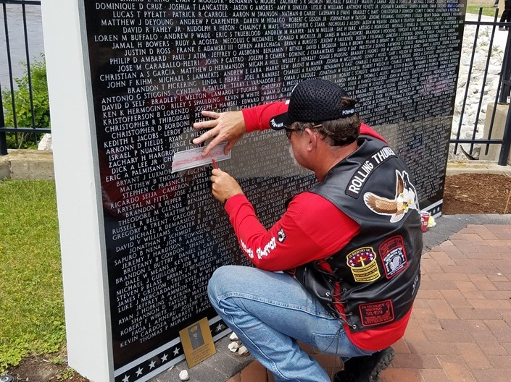Opportunity to make a Rubbing of a fellow Comrade or friend
Ride Agenda

Friday June 18, 2021

09:00 - 09:45 - Staging and Registration.

09:45 - 10:00 Prepare for Departure.

10:00 - KSU

Estimated Arrival Time: 16:00 CST

Staging Location: Fort Harrison Veterans Center, 9450 East 59th Street Indianapolis, IN 46216.

Saturday June 19, 2021

Please Note: (The time has changed to Central Time)

06:30 – Wake Up Call.

07:00 – 08:00 Breakfast at Holliday Inn.

*08:00 – Depart Holiday Inn to Grundy County Fairgrounds for Staging (See below note).

10:30 – Ride departs for Marseilles, IL.

13:00 – Attend The Middle East Conflicts Wall Memorial Program.

*Note: A $15.00 ( Cash Only ) per person Donation will be required at the Gate.

08:00 - Wake Up Call.
Sunday June 20, 2021

08:00 - 09:00 Breakfast at Holiday Inn.

09:00 - Depart back to Indianapolis.

14:00 - Estimated arrival time in Indianapolis.

Hotel Information

We have a block of rooms at the Holiday Inn Express Morris, IL, The Hotel rate is $104.99. The cutoff
date for Reservations is May 28, 2021. Hotel: Holiday Inn Express Mor ris Address: 222 Gore Road Mor ris, IL 60540
Reservation Number: 815-941-8700
Check In Date: J une 18, 2021
Check Out Date: J une 20, 2021
Group Name: Rolling Thunder Indiana Chapter 1
Group Code: RTG
Rate: $104.00 Plus 11% Room Tax

Contact Information: Mike Clar k, Email: mike.clar k@indianarollingthunder.com, Phone Number:317-991-3085

“We Ride for Our Brothers that Can’t”
Rolling Thunder, Inc. Indiana Chapter #1
Ride to the Middle East Conflicts Wall Memorial

Registration Form
(One person only per registration form, Please clearly print all required information)

Name: |  | Handle:
Address:

City: State: Zip:
Cell Phone: | email:
Emergency Contact Name: |  | Phone:
Special Needs (meds, conditions, etc.

Check the Appropriate “YES” or “NO” Box Yes No
I am a first responder and available to help in case of an emergency

Yes No Yes No
I am a Veteran |  |  | I am a Rolling Thunder member
I am the bike driver |  |  | I am driving a 4-wheeler
I am a passenger |  |  | I am driving a trike

Note: Please complete the form and email to the address listed below or mail to the
Chapter mailing address. Please do not list Rider or Passenger as the Emergency Contact.
Contact Mike Clark @ 317-991-3085 for any questions.

Email: mike.clark@indianarollingthunder.com

Chapter Mailing Address

Rolling Thunder Indiana Chapter 1
P.O Box 26458
Indianapolis, IN 46226

Signature of registrant: Date:

