Welcome to the new douglascountyhog.com!!
The douglascountyhog website has been migrated to a website platform called Hogscan. All the content from our old site has been migrated to the new one including the pictures.

Frequently Asked Questions

Q: How do I create my account?
A: Look for an email from webmaster@douglascountyhog.com. It contains the instructions on how to setup your account:
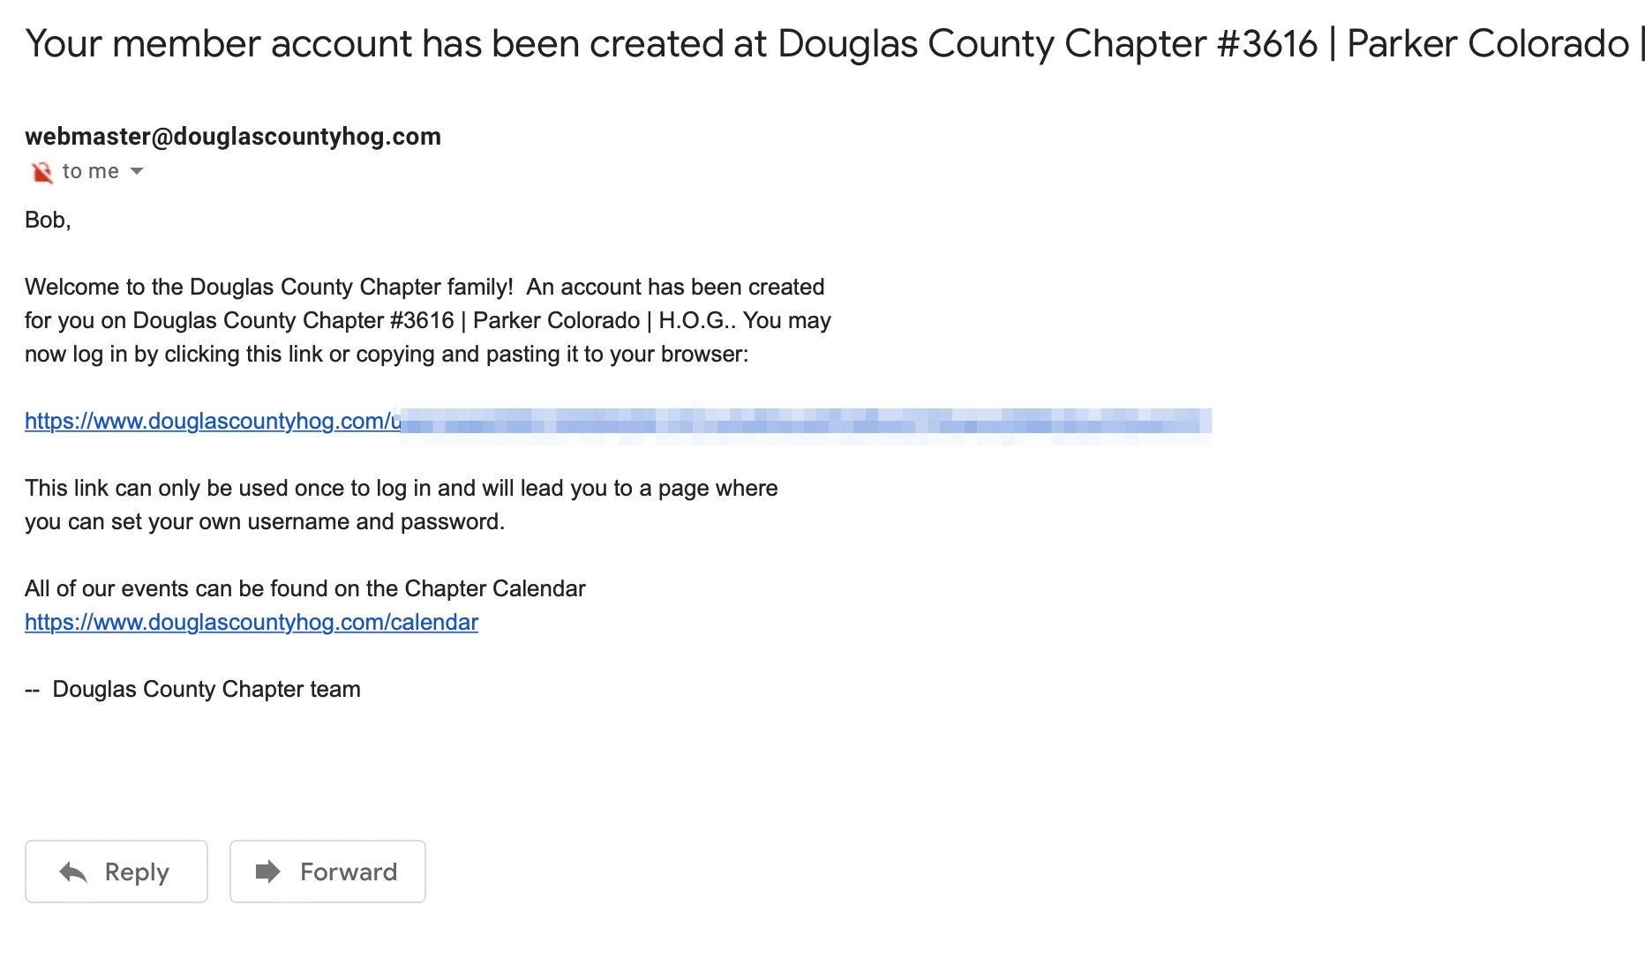

Q: How do we log into the website?
A: Open your browser and go to https://douglascountyhog.com.

Q: I forgot my password. How do I reset it?
A: Select request new password and enter either your email address or your HOG ID:
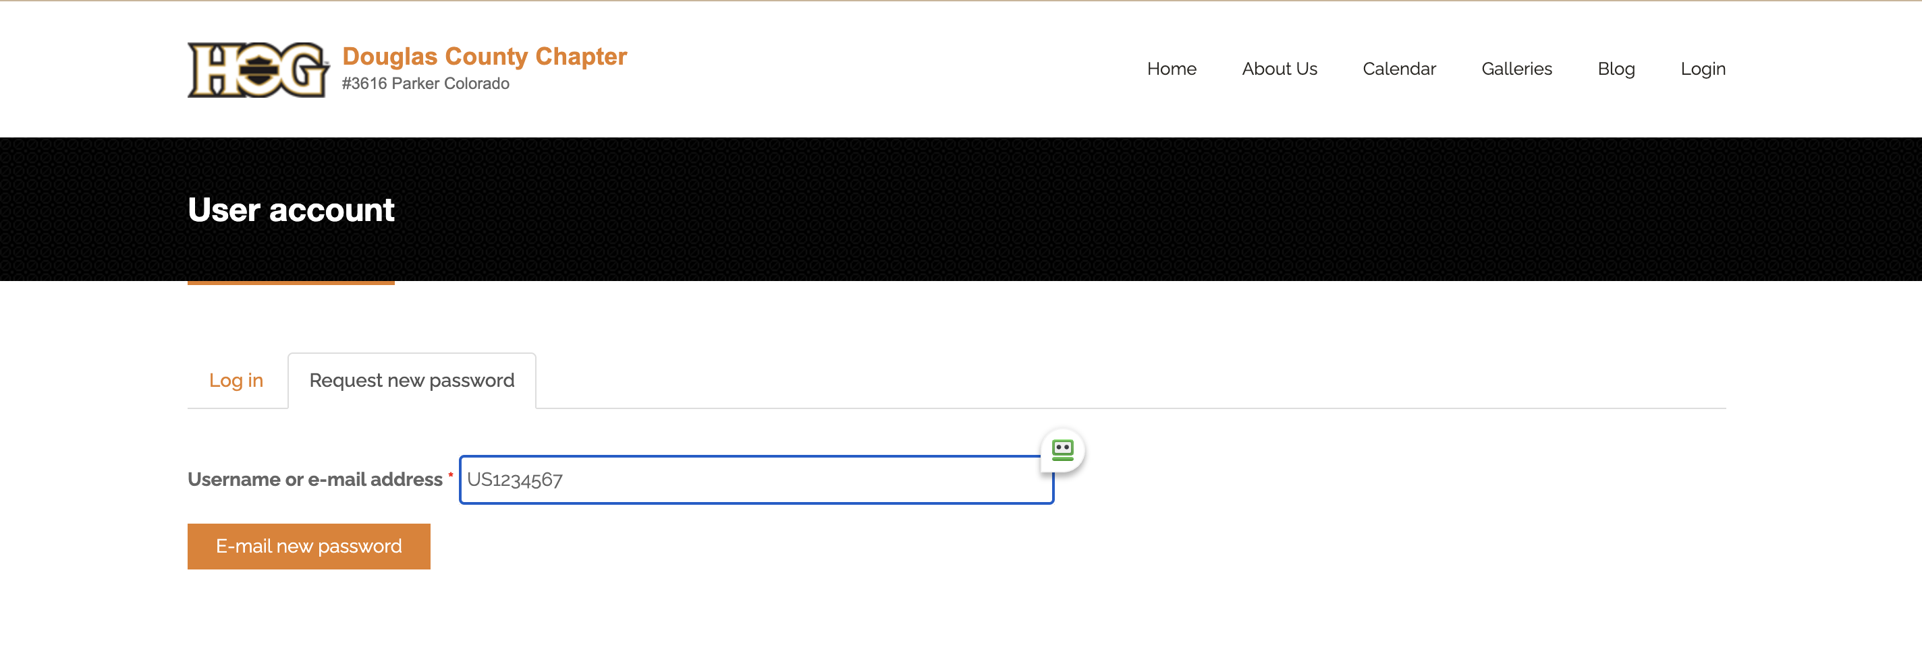

Q: I am logged in. Where do I find the chapter events?
A: All events are now in the calendar on the website:
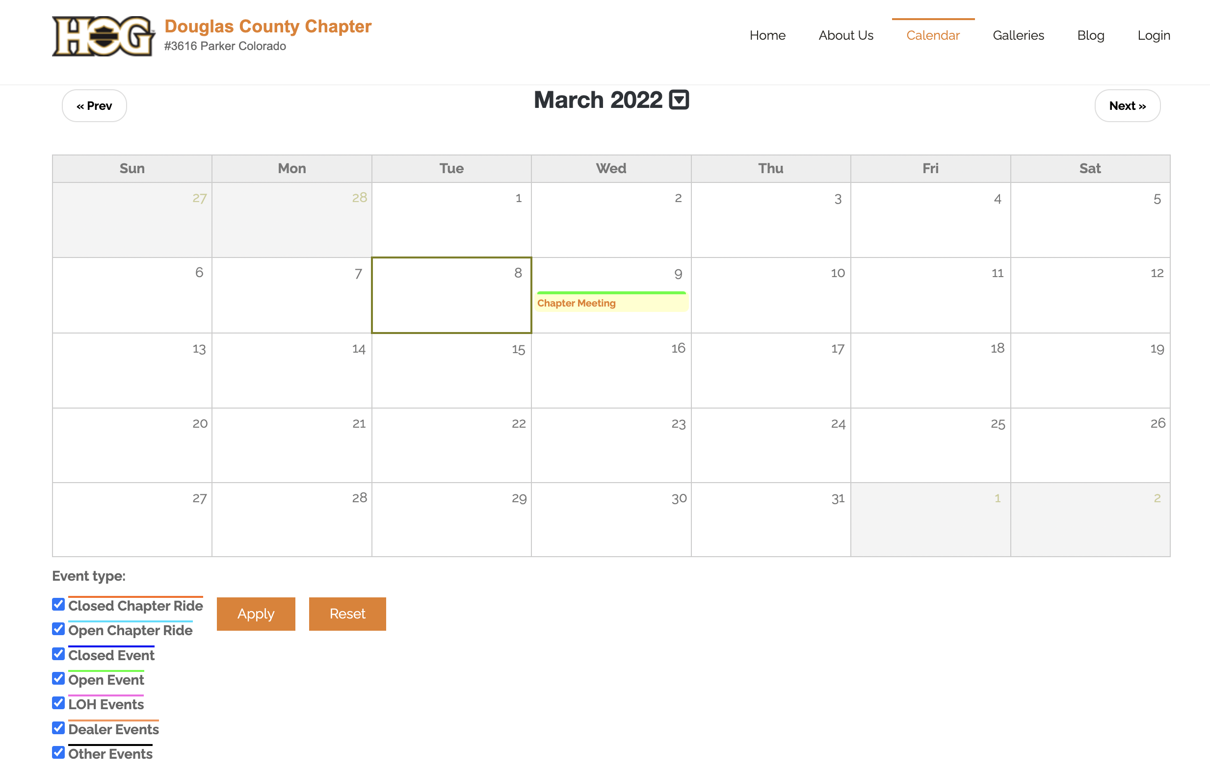

Q: How do I subscribe to the calendar using my android phone?
A: You have to use your computer to add a calendar (android limitation). Open your desktop browser and go to https://calendar.google.com. On the left side, click on the plus sign (+) next to Other Calendars:
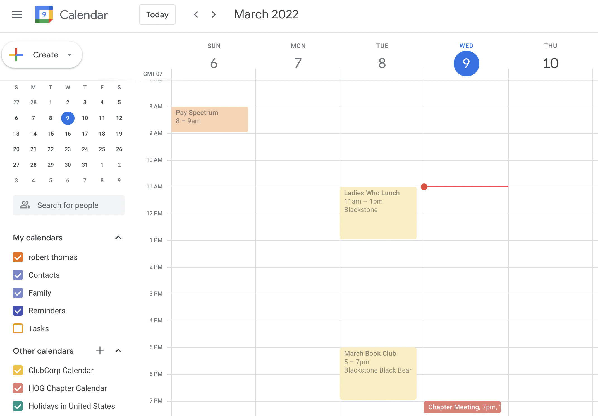
Next, select Subscribe to Calendar:
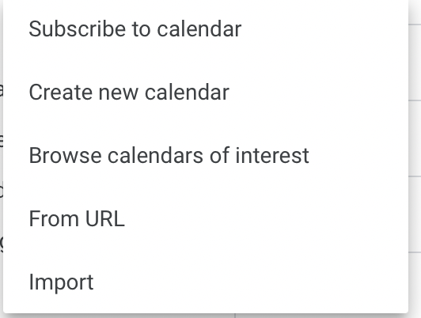
Select From URL, enter the URL of calendar as webcal://douglascountyhog.com/calendar/feed and select the button Add calendar:
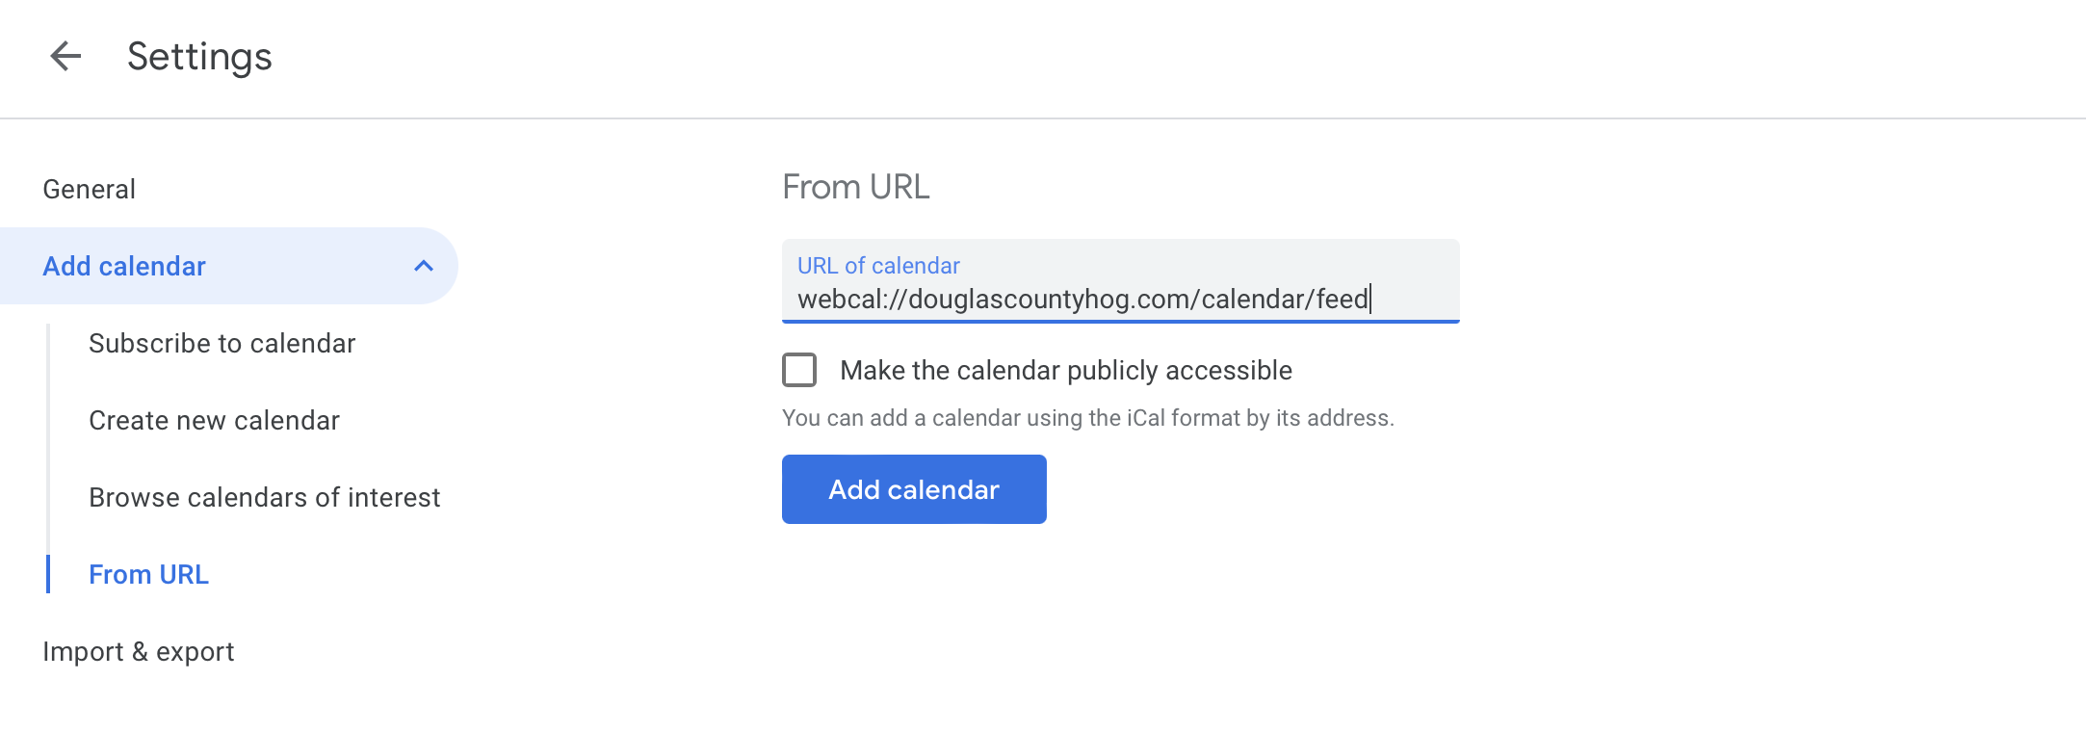
Now you can go to your phone and in the calendar app make sure the HOG Chapter Calendar is selected. Sometimes it takes a while for your phone to sync to get the calendar added to your phone. If it is not there, wait an hour and check again.
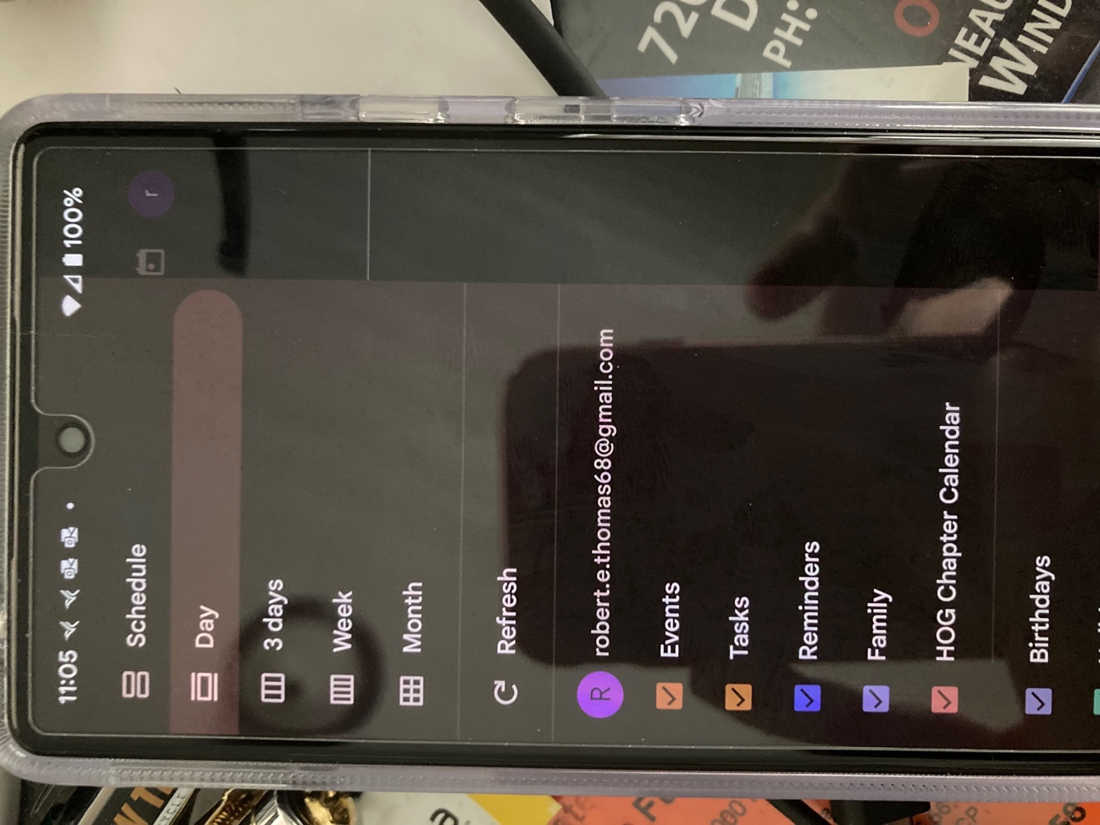

Q: How do I subscribe to the calendar using my iphone?
A: Go to the calendar and select subscribe:
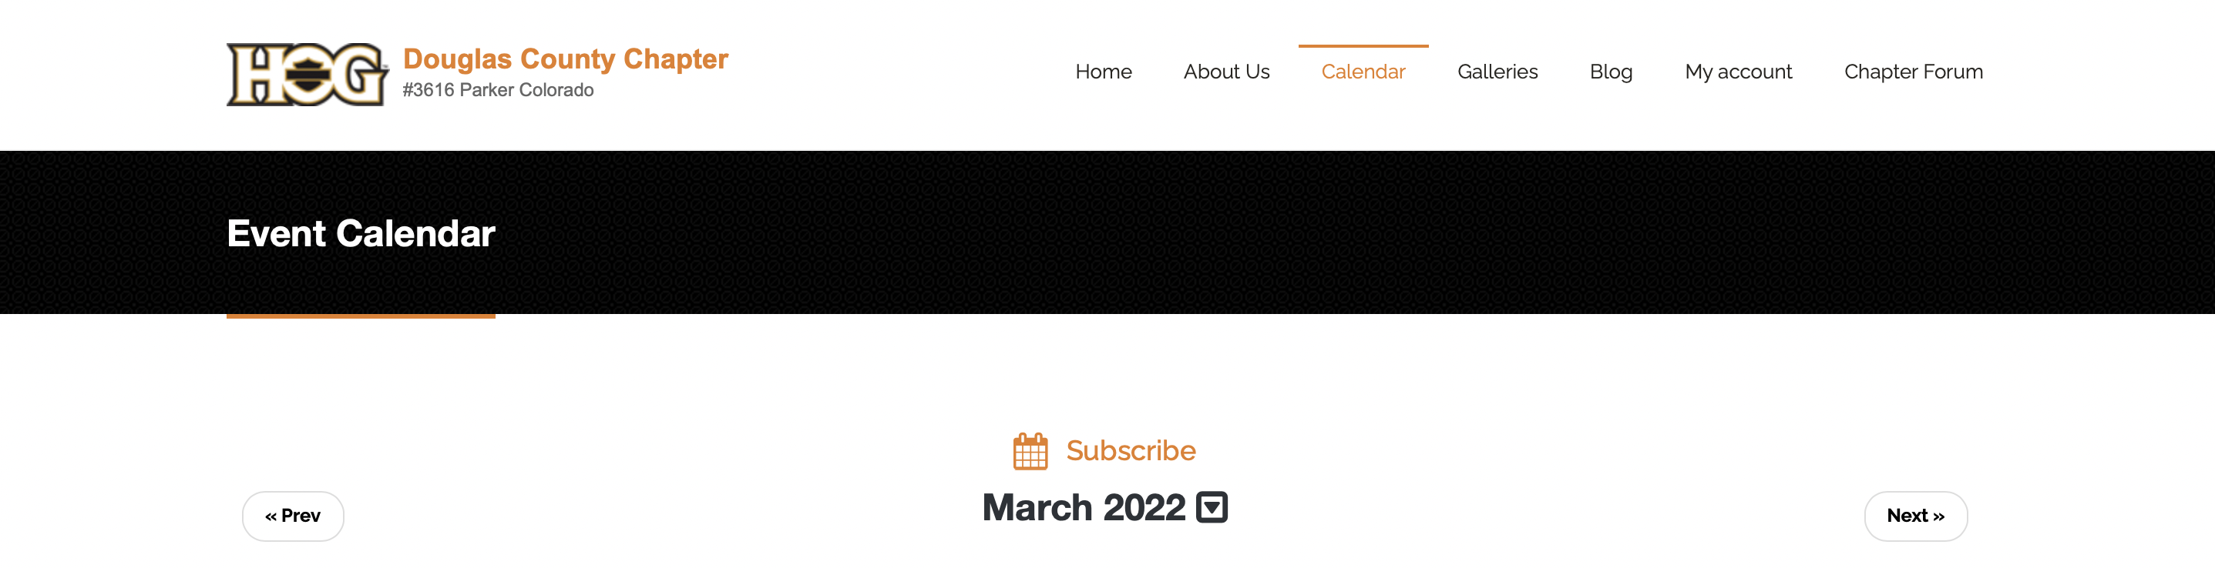
Click on Allow:
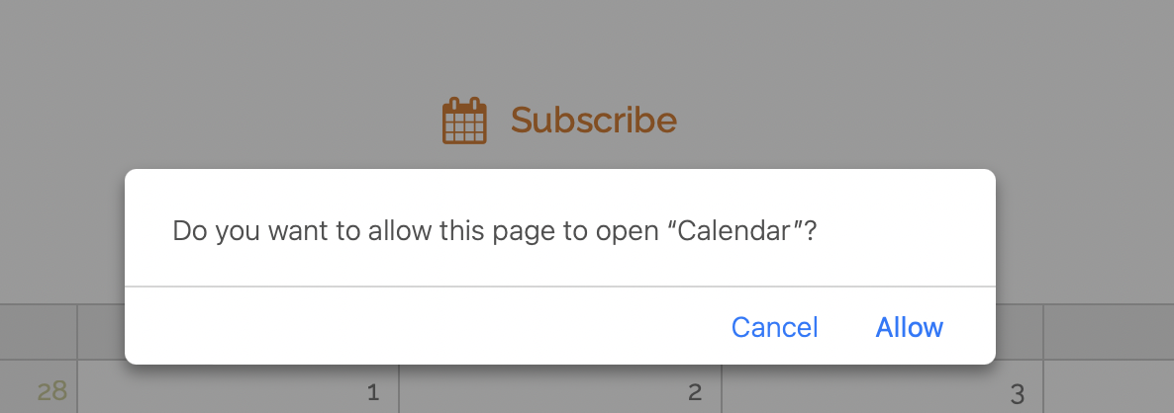
Click on Subscribe:
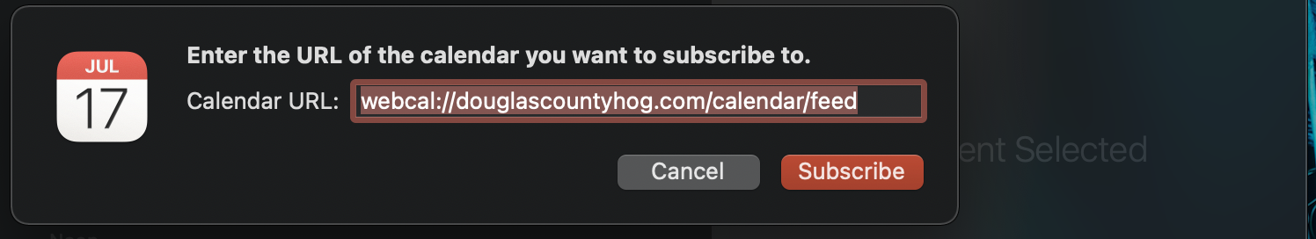

Q: What does ICE mean:
A: In Case of Emergency

Q: How do I update my ICE contact?
A: Make sure you are logged into the website. Select My account and Edit:
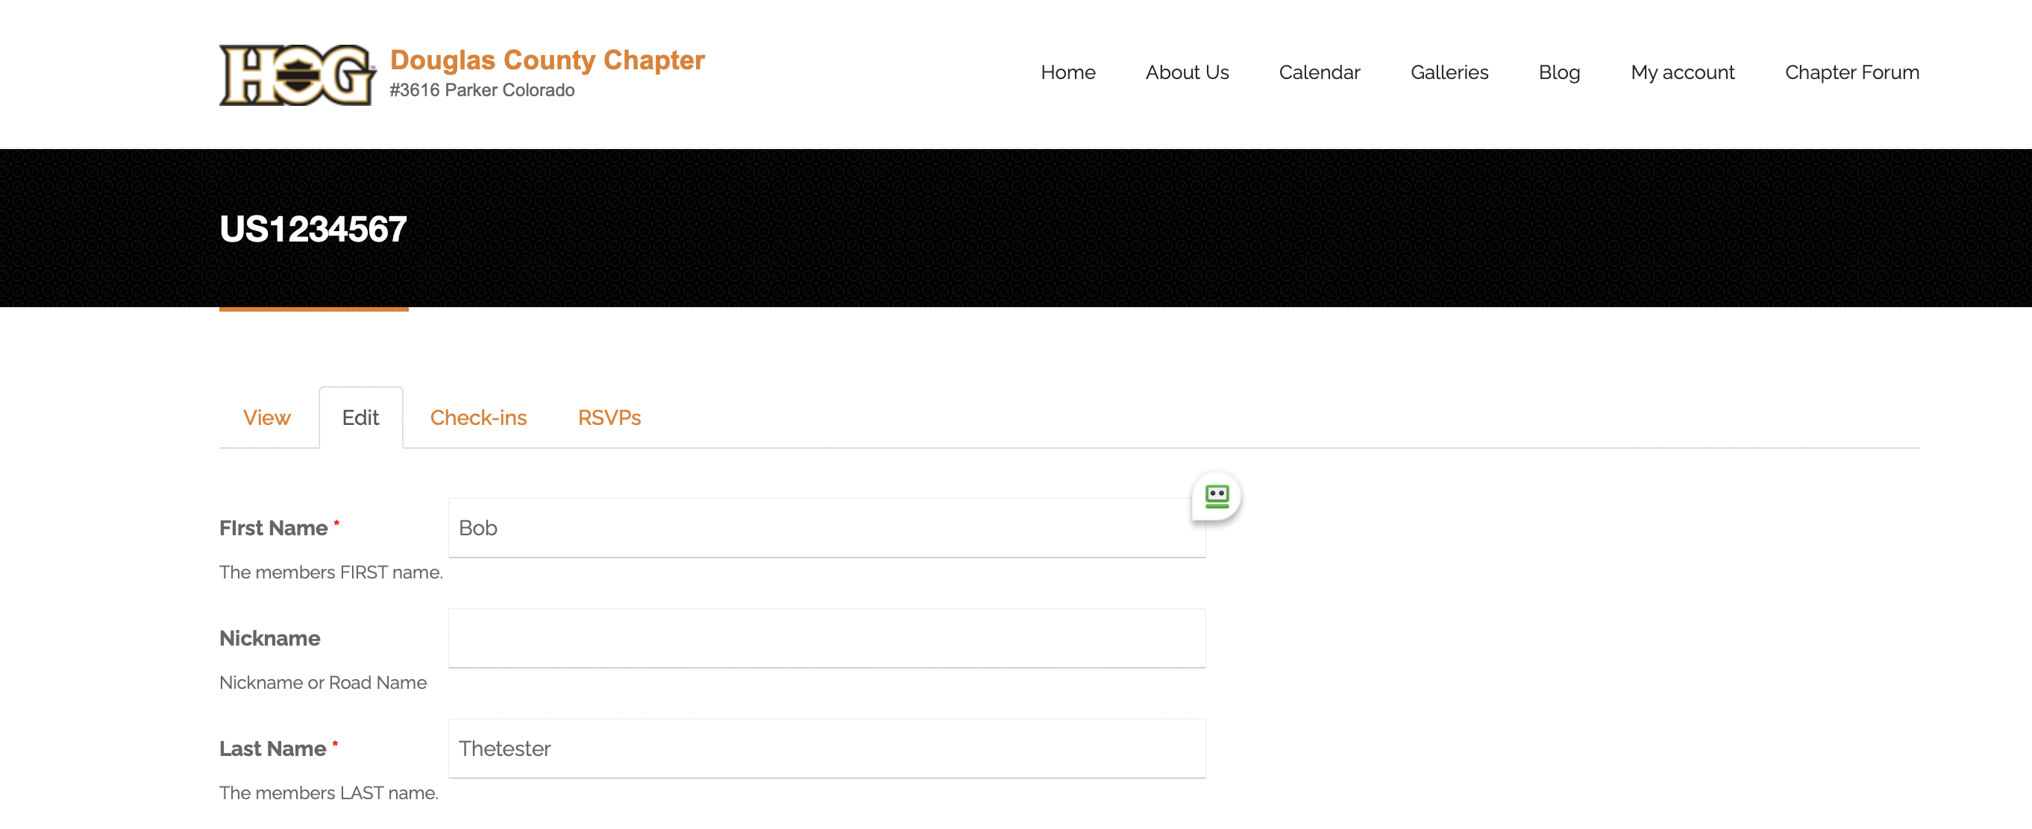
Scroll down towards the bottom of the page to find Emergency Contact Name and Phone:
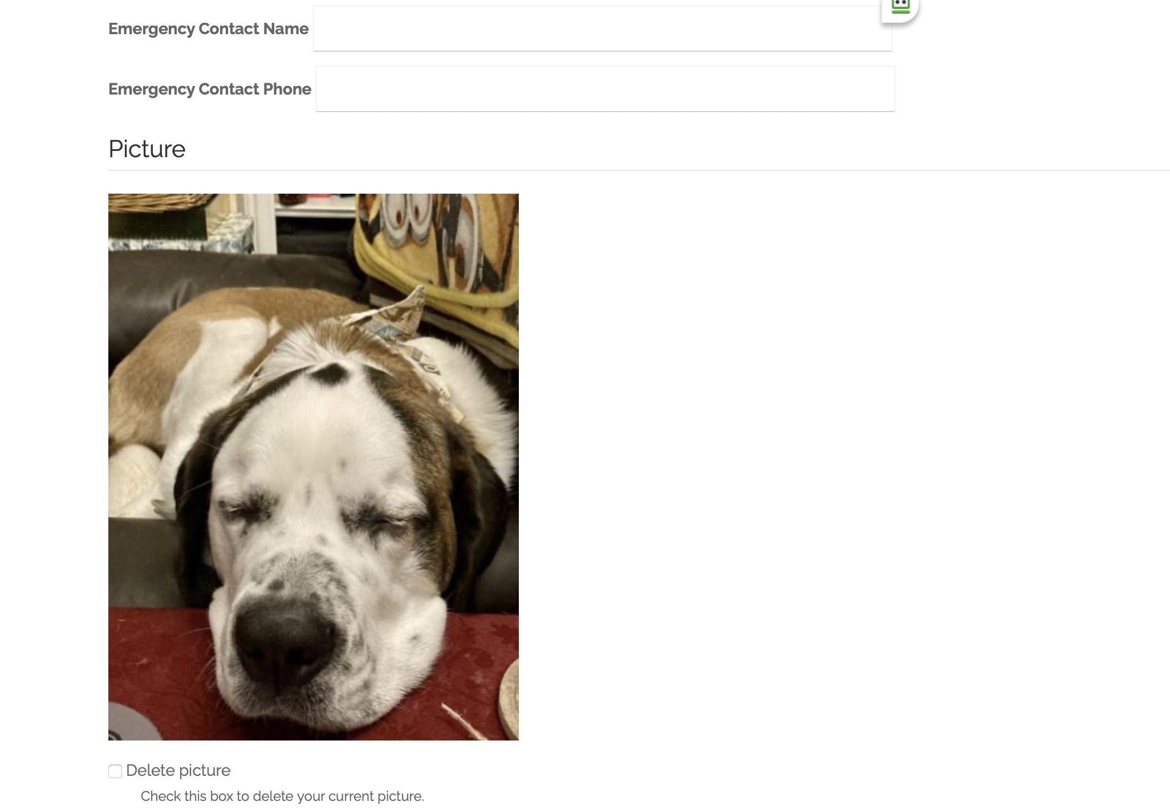
You can also add other info like your phone number, allow us to send you text messages, upload a photo, etc.

Q: What if I have additional questions or need help?
A: Send an email to webmaster@douglascountyhog.com

